Changing the shape of the bar giving it a different visual design.

Using colour and a numeric value to visually show how the player is progressing.

Having different colours and patterns to show the players progression.

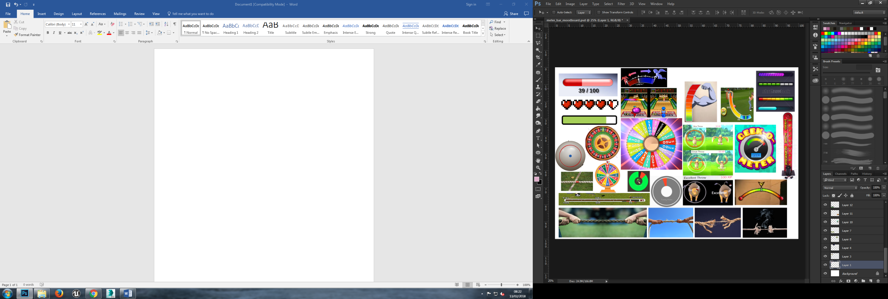

Using the example of Pokemon Go to show how the player can time the success of their throws by monitoring how close the coloured circle is to the white circle.

Using the circle timer as an example of other ways time can be represented and display success or failure.

Looking at other examples of games using a wheel or circle that represent the mechanic of chance rather than timing such as Roulette or The Wheel of Fortune.

Another way to visually show the player is progressing is to use icon to represent such as these hearts.

Having a simple bar with one colour to clearly indicate how much “pull power” the player has. Minimal, simple and clear design to telegraph information to the player.

Visual feedback by having the rope tear with loose threads and seams splitting to represent tension and force.

Using the rope or object the players contest over to show how well the players are doing with no other information other than the object their pulling.